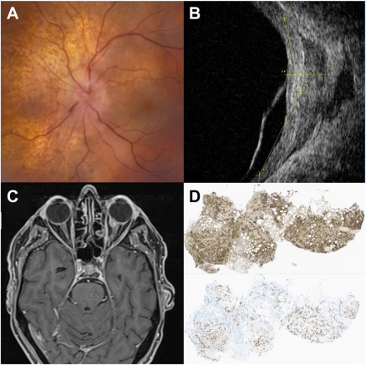

A 78-year-old man with history of esophageal adenocarcinoma, in remission 9 months after resection, chemotherapy, and radiation,presented with a peripapillary choroidal lesion with leopard-spot pigmentation and disc edema (A). Extraocular extension was demonstratedon B-scan and magnetic resonance imaging (B, C). A transconjunctival orbitotomy approach was performed rather than choroidal fine-needlebiopsy to maximize tissue yield. Histopathology revealed expression of keratin (D), cytokeratin 20, caudal-related homeobox transcriptionfactor 2 (CDX-2), and cytokeratin 7. Positron emission tomography scan showed noprimary tumor recurrence or additional metastases.Based on the provided images and clinical description please make an ophthalmic diagnosis for this patient. And output the diagnostic conclusions only.

**Metastatic carcinoma to the choroid and orbit**